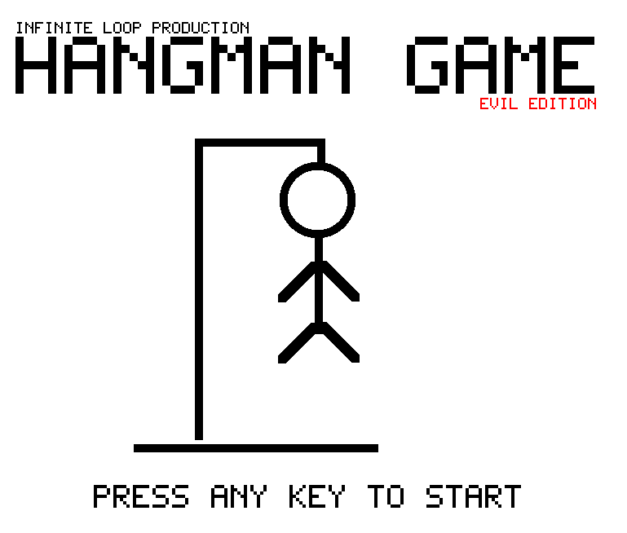

Baylor University – ECS

Cashion Academic Center

1401 S. 4th Street

Room 308

Phone: 765-444-9527

Fax: 765-444-9527

E-mail: peter_wang@baylor.edu

Baylor University – ECS

Cashion Academic Center

1401 S. 4th Street

Room 308

Phone: 765-444-9527

Fax: 765-444-9527

E-mail: peter_wang@baylor.edu

**TABLE OF CONTENTS**

**TABLE OF CONTENTS ……………….…… 1**

**INTRODUCTION …………….……...……….. 2**

**SYSTEM REQUIREMENT ……….………. 3**

**HOW TO PLAY ……….……..……………..… 4**

**CREDITS ………………...………..……………. 6**

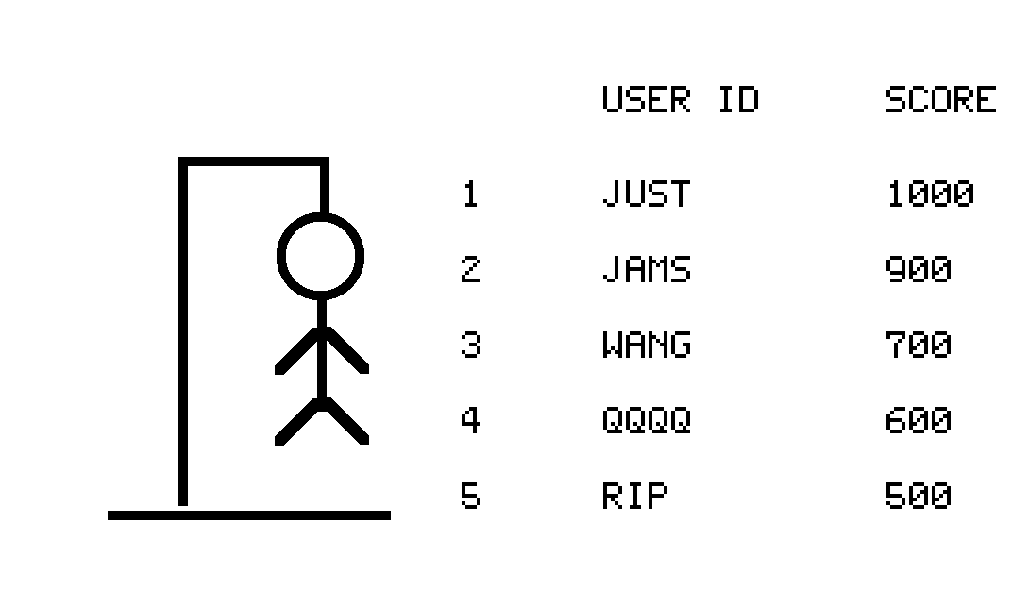

**INTRODUCTION**

**The history of “Evil Hangman” started in 2017. Justin Yu, Hayden Householder, Jorge Adrian Moreno, Jingyu Wang and Chunyang Yin came up with a hangman game which is almost impossible to beat. The game allows you to choose from three difficulties: easy, medium and hard. Each difficulty has a different word length. If you somehow manage to beat the game then the game will ask you to input your name that is four characters long and if your score is indeed a high score then it will be recorded on the screen.**

**\*\*WARNING: THIS GAME CAN MAKE YOU EMOTIONALLY UNSTABLE, PLEASE PLAY AT YOUR OWN RISK.**

**SYSTEM REQUIREMENT**

Pentium II 300 MHz/compatible or above

32 MB RAM memory

50 MB free hard drive space for installation of the game

Windows 95/98/2000/XP/VISTA/7/8/10

DirectX Certified Video Card capable of supporting 720x1280 resolution mode

DirectX-compatible Sound Card

Keyboard and mouse

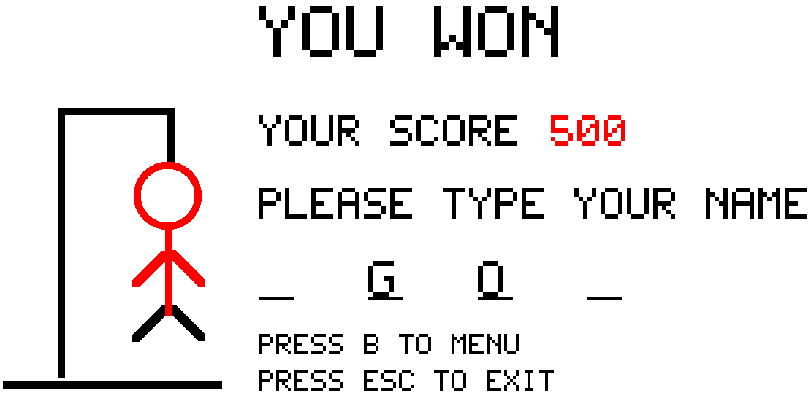

**HOW TO PLAY**

When you first start the game, the start game page will show up and it will ask you to enter any key to start. Then it will take you to the main game menu, you can navigate through the menu with the up and down arrow key, you can choose any of the three difficulties to play on, which are easy (four letters and twelve tries), medium (seven letters and seven tries) and hard (eight letters and six tries) by pressing the left or right arrow key while on the “LEVEL” toggle switch. Also, if you do not like the music playing in the background, you may turn the “MUSIC” toggle switch to off. Once you have selected the correct options then navigate to “START” and press enter, this will start the actual game. Once the game is started, to guess a letter simply press the letter you want on the keyboard and if correct, it will fill up the space where the letter reside(s) on

the screen. Otherwise, the letter will be added onto the incorrect letter list and a body part will be drawn on screen. If you somehow manage to beat the game, it will check your score against all the other high scores on the list and if your score is higher, the game will prompt you for your name (four characters), your name will then be displayed on the “PLAYERS” screen.

Please note: The game itself is evil, so you must finish the game completely or your score will not be counted. ☺

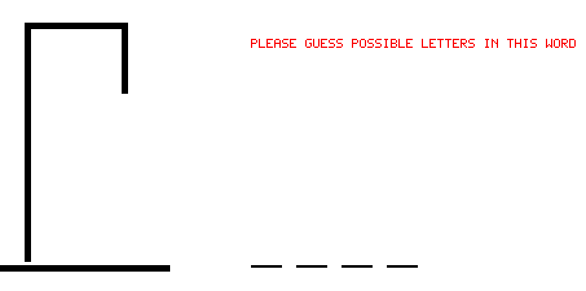

**CREDITS**

**Infinite Loop**

**Graphics design:**

Hayden Householder

Jingyu Wang

Chunyang Yin

**Logic design:**

Justin Yu

Jorge Adrian Moreno

**Sound producer(s):**

Jingyu Wang

Chunyang Yin

**ALPHA Tester(s):**

Justin Yu

Hayden Householder

Jorge Adrian Moreno